Object Detection



Session: 2023 – 2027

Submitted by:
Khadija Saeed 2023-CS-74

Supervised by:
Dr. Waseem / Dr. Usman

Course:
Computer Vision

Department of Computer Science
University of Engineering and Technology
Lahore Pakistan

Objective
The objective of this project was to develop an object detection system capable of identifying Personal Protective Equipment (PPE) adherence and non-adherence in healthcare environments. The system automatically detects various PPE components worn by healthcare workers and identifies missing or incomplete protective equipment.

Dataset Description
The dataset consisted of medical and clinical environment images annotated with PPE-related classes. A total of 18 object classes were used:

PPE Adherence and Non-Adherence Classes (17 Classes)
- Gown_Absent
- Gown_Incomplete
- Gown_Complete
- Glove_Absent
- Glove_Complete
- Regular_Mask_Complete
- Mask_Absent
- Mask_Incomplete
- N95_Complete
- N95_Strap
- Face_Shield_Complete
- Face_Shield_Incomplete
- Eyewear_Absent
- Safety_Glasses
- Additional PPE adherence/non-adherence categories present in the dataset annotations

Additional Class
- Head
The PPE classes represent different levels of compliance, while the Head class was used to identify healthcare personnel and assist in PPE compliance assessment.
The original dataset contained:
- 10,034 images
- 123,751 annotations
- 18 object classes
For experimentation, a subset of the dataset was used for training and validation.

Methodology

Data Preparation
- Dataset annotations were provided in COCO format.
- COCO annotations were converted into YOLO format.
- Images and labels were split into training and validation sets.
- A YAML configuration file was created for YOLOv8 training.

Model Selection
The YOLOv8 Nano (YOLOv8n) object detection model from the Ultralytics framework was selected due to its lightweight architecture, fast inference speed, and suitability for real-time detection tasks.

Training Configuration
- Model: YOLOv8n
- Image Size: 640 × 640
- Epochs: 100
- Hardware: NVIDIA Tesla T4 GPU
- Framework: Ultralytics YOLOv8
- Deep Learning Backend: PyTorch
The model was trained to detect PPE components and classify them into their respective adherence and non-adherence categories.

Training Results
At the completion of 100 epochs, the final training losses were:
Metric | Value
Box Loss | 1.475
Classification Loss | 1.224
DFL Loss | 1.450
Training completed successfully in approximately 0.111 hours.

Overall Validation Performance
After validation using the best trained model, the following performance metrics were obtained:
Metric | Value
Precision (P) | 0.800
Recall (R) | 0.467
mAP@50 | 0.513
mAP@50-95 | 0.236
These results indicate that the model achieved good precision, meaning most detected PPE items were correctly classified, while recall shows that some objects were still missed during detection.

Class-wise Performance

Class | Precision | Recall | mAP@50 | mAP@50-95
Gown_Absent | 1.000 | 0.692 | 0.995 | 0.330
Gown_Incomplete | 1.000 | 0.000 | 0.152 | 0.033
Gown_Complete | 0.681 | 0.826 | 0.865 | 0.586
Glove_Absent | 0.691 | 0.735 | 0.767 | 0.274
Glove_Complete | 0.773 | 0.429 | 0.606 | 0.274
Regular_Mask_Complete | 1.000 | 0.000 | 0.003 | 0.001
Mask_Absent | 0.411 | 0.571 | 0.409 | 0.110
Mask_Incomplete | 0.751 | 0.735 | 0.753 | 0.311
N95_Complete | 1.000 | 0.000 | 0.024 | 0.002
N95_Strap | 1.000 | 0.000 | 0.000 | 0.000
Face_Shield_Complete | 0.467 | 0.550 | 0.399 | 0.165
Face_Shield_Incomplete | 0.863 | 0.935 | 0.955 | 0.606
Eyewear_Absent | 0.599 | 0.718 | 0.642 | 0.210
Safety_Glasses | 1.000 | 0.000 | 0.247 | 0.074
Head | 0.772 | 0.816 | 0.879 | 0.558

Inference Performance
The trained model achieved the following inference speed:
- Preprocessing: 0.2 ms per image
- Inference: 1.3 ms per image
- Postprocessing: 2.5 ms per image
This demonstrates that the model is capable of near real-time PPE detection.

Samples

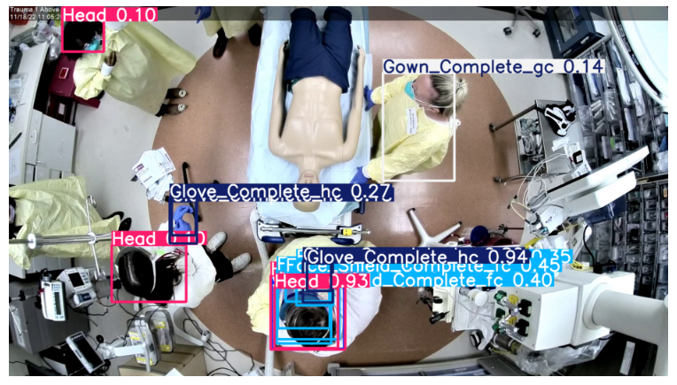
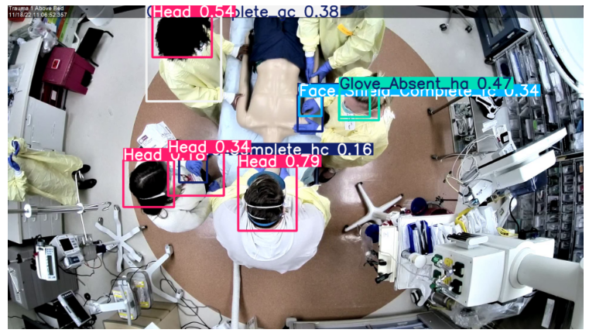

Conclusion
A YOLOv8-based object detection system was successfully developed to identify PPE adherence and non-adherence in healthcare environments. The model learned to detect multiple PPE categories including masks, gloves, gowns, face shields, eyewear, and healthcare worker heads.
The final model achieved:
- Precision: 80.0%
- Recall: 46.7%
- mAP@50: 51.3%
- mAP@50-95: 23.6%
The results demonstrate that deep learning-based object detection can effectively support automated PPE monitoring and compliance assessment in clinical settings. Future improvements can be achieved by training on the complete dataset, increasing image resolution, applying data augmentation, and utilizing larger pretrained YOLO models.

